**Zero Downtime Deployment with Deployment Strategies**

**What is Zero Downtime Deployment?**

Bhai, Zero Downtime Deployment ka matlab hota hai:  
*"Application ka naya version deploy karte waqt users ko bilkul bhi service ka interruption (band hone ka time) na ho."*

Simple terms mein:

* Users ko pata bhi na chale ki peeche kuch update ho raha hai.
* Website ya app ek second ke liye bhi down nahi honi chahiye.

**Zero Downtime Matters because:**

1. **Customer Experience Smooth Rehta Hai**
   * Agar site ya app down hui, users irritate hote hain.
   * Continuous smooth service se trust banata hai.
2. **Revenue Loss Nahi Hota**
   * Jaise shopping website band hui, to direct sale loss hota hai.
   * Especially big apps (Amazon, Netflix) ke liye har second ka paisa important hota hai.
3. **Brand Reputation Safe Rehti Hai**
   * Frequent downtime se log bolte hain: "Yeh app to unreliable hai."
   * Achha brand image maintain karne ke liye uptime zaroori hai.
4. **No Impact on SEO**
   * Agar website downtime mein catch ho gayi, Google SEO ranking bhi gir sakti hai.
5. **Business Continuity Bani Rehti Hai**
   * Backend processes, payment gateways, APIs — sab smoothly chalte hain bina ruke.
6. **Better User Retention**
   * Agar app ya service hamesha available hai, users baar-baar aayenge.

**Simple line mein: “**Zero downtime = Happy Users + Happy Business**"**

**Key Concepts Associated with Zero Downtime 🚀**

* **High Availability (HA)**➔ System kabhi down na ho, chahe kuch components fail ho ya update ho rahe ho.  
  ➔ Backup servers, auto-scaling, load balancers use hote hain.
* **Immutable Deployments**➔ Purani app ko modify nahi karte, ek nayi clean version deploy karte hain.  
  ➔ "Don't patch, replace."
* **Blue-Green Deployment**➔ 2 environments ready rehte hain:
  + Blue = Old version
  + Green = New version  
    ➔ Traffic ko Blue se Green par ek saath switch kar dete hain without downtime.
* **Canary Releases**➔ Update pehle thode se users ko dikhate hain.  
  ➔ Agar sab thik raha to full rollout karte hain.  
  ➔ Safe testing in live environment.
* **Graceful Shutdown**➔ Server ko immediately band nahi karte.  
  ➔ Pehle existing requests complete karne dete hain fir process kill karte hain.
* **Rolling Updates**➔ Sare servers ek saath update nahi karte.  
  ➔ Ek-ek karke update karte hain, baki service chalu rehti hai.

**🚀 Deployment Strategies for Zero Downtime**

Deployments ko safe aur smooth banane ke liye yeh strategies use hoti hain:

**1. Blue-Green Deployment**

**Concept:**

* Do identical environments (Blue & Green).
* Blue = live traffic. Green = updated version.
* Testing ke baad traffic switch karte hain.

**Workflow:**

1. Blue live, Green idle.
2. Green mein new version deploy karo.
3. Green par testing (smoke/integration tests).
4. Traffic ko Blue se Green par switch karo.
5. Blue becomes backup.

**Benefits:**

* Instant rollback possible.
* Safe testing in production-identical environment.

**Trade-offs:**

* Double infrastructure cost.
* DNS/Load Balancer setup thoda complex.

**2. Canary Deployment**

**Concept:**

* Naya version thode users ko rollout karte hain → phir dheere-dheere sabko.

**Workflow:**

1. 5% users ko update do.
2. Monitor (errors, latency, logs).
3. Agar sab theek ho, 25%, 50%, 100% tak rollout badhao.

**Benefits:**

* Problems early catch kar sakte ho and Real user feedback milta hai.

**Trade-offs:**

* Complex deployment scripts.
* Real-time traffic splitting zaruri.

**3. Rolling Update**

**Concept:**

* Ek-ek karke servers/containers update karte hain.

**Workflow:**

1. N servers mein se ek ko offline karo.
2. Update aur restart karo.
3. Repeat for all.

**Benefits:**

* No duplicate infra needed and Easy with containers/Kubernetes.

**Trade-offs:**

* Rollback slow aur tough hota hai.
* Partial failures se users impact ho sakte hain.

**4. Feature Toggles (Feature Flags)**

**Concept**:

* Code production mein hota hai, par features hidden hote hain.
* Feature ON/OFF config flags se manage karte hain.

**Use Cases:**

* Internal users ke liye gradual rollout.
* A/B Testing.
* Instant feature disable without deployment.

**Benefits:**

* Deployment ≠ Release.
* Feature-specific risk control.

**Trade-offs:**

* Code complexity badhta hai.
* Flags ko timely clean karna padta hai (varna technical debt).

**5. Shadow Deployment**

**Concept:**

* Nayi version ke server ko real traffic duplicate bhejte hain.
* Users ko actual response nahi dikhta.

**Benefits:**

* Safe large-scale performance testing.
* New architecture ya big rewrites test kar sakte hain.

**Trade-offs:**

* High resource usage.
* Traffic duplication ka setup complex hota hai.

🎯 **Choosing the Right Strategy**

**Depends on:**

* Team skill & tools.
* Application architecture (Monolith vs Microservices).
* Traffic volume and risk.

**Examples:**

* Startups ➔ Rolling Updates + Feature Toggles
* Enterprises ➔ Canary + Blue-Green Combo for critical services.

🛠 **Tooling for Support**

* Kubernetes ➔ Rolling Update, Canary rollout native support
* AWS CodeDeploy, ECS, EKS ➔ Blue-Green and Canary deployment
* Argo Rollouts, Spinnaker ➔ Progressive delivery automation
* LaunchDarkly, Unleash ➔ Feature Toggle management tools

**One Line Summary:**

"Zero Downtime Deployment ensures updates happen without hurting user experience, business, or developer confidence." 🔥

**🏗️ 3. Application Architecture Considerations for Zero Downtime Deployment**

**1. Stateless Applications**

App should not depend on local memory or local files.

**Why Important:**

* Instances can shut down or restart anytime without losing data.
* Easy scaling and rolling updates.

**Best Practices:**

* Use external session stores: Redis, Memcached.
* Store files on external storage: Amazon S3.
* APIs should be idempotent and stateless.

**2. Graceful Startup and Shutdown**

Handle app boot and app exit smoothly without killing live requests**.**

**Startup Tips:**

* App should accept traffic only after full readiness.
* Use readiness probes (e.g., in Kubernetes).

**Shutdown Tips:**

* Stop accepting new requests immediately.
* Finish ongoing requests gracefully.
* Clean up connections, flush logs.

**Tools/Techniques:**

* Handle SIGTERM signals.
* preStop hooks in Kubernetes.
* Application lifecycle hooks in frameworks like Spring Boot, ASP.NET Core.

**3. Backward-Compatible Changes**

Old and new versions must co-exist safely during deployment.

How:

* Avoid breaking API contracts.
* Make additive DB schema changes (never destructive).
* Support versioned APIs.

**Example:**

* Instead of renaming a DB column ➔ Add new column ➔ Use both ➔ Later remove old.

**4. Decoupled Components & Microservices**

Break monolith into smaller independent deployable units**.**

**Benefits:**

* Deploy one service without touching others.
* Isolate failures.
* Easier Canary/Feature Toggle use.

**Best Practices:**

* Communicate via queues (RabbitMQ, Kafka).
* Define clear contracts for services.
* Handle partial failures (fallbacks/retries).

**5. Resilience & Fault Tolerance**

System should survive temporary failures.

**Patterns:**

* Circuit Breakers: Stop cascading failures.
* Retries with Exponential Backoff: Handle temporary errors.
* Fallbacks: Show graceful degraded behavior.

**Libraries:**

* Polly (for .NET)
* Resilience4j (for Java)
* Istio (for service mesh)

**6. Observability Built-In**

You can’t deploy safely if you don’t know what’s happening inside your app.

**Architecture Additions:**

* Detailed logging (at every request/response).
* Metrics (latency, error rates, throughput).
* Tracing (OpenTelemetry, Jaeger).

**Benefits:**

* Instantly detect deployment issues.
* Correlate errors to specific versions/components.

**7. Idempotent Endpoints**

Every API endpoint should be idempotent—calling it multiple times shouldn’t cause different results. This is critical for retry-safe deployments and graceful recovery from transient failures.

**Why Important:**

* Safe retries during deployments or network glitches**.**

**Example:**

* Payment API: Prevent double charging using unique request IDs.

**8. Version-Aware Clients**

Every API endpoint should be idempotent—calling it multiple times shouldn’t cause different results. This is critical for retry-safe deployments and graceful recovery from transient failures.**Techniques:**

* URI Versioning ➔ /api/v1/users
* Header-Based Versioning
* Media Type Versioning (e.g., HATEOAS)

**🔥 Quick Summary One-Liner**

"Zero downtime is not just about how you deploy; it's about how you *design* your app to survive deployments."

**🚀 Key Stages of a CI/CD Pipeline for Zero Downtime**

**1. Code Commit & Version Control**

Saara game yahin se start hota hai — jab developer Git repo (GitHub, GitLab, Bitbucket) mein code commit karta hai.

**Best Practices:**

* Branch protection rules lagao (direct main branch par push nahi).
* Code review aur linting mandatory banao.
* Releases ko semantic versioning ke saath tag karo (e.g., v1.0.0).

**2. Build Stage**

Code ko compile karna, dependencies install karna aur build artifact (Docker image ya binaries) banana.

Example (.NET Core app build via GitHub Actions):

- Checkout Code

- Setup .NET 7.0

- dotnet build --configuration Release

- dotnet publish -c Release -o out

- Docker build: docker build -t myapp:${{ github.sha }}

**3. Test Stage**

Build ke baad testing zaruri hai — kuch bhi tod-phod ho toh yahin pakad lo.

**Include karo:**

* Unit tests
* Integration tests (mock services ke saath)
* Load/performance tests (staging mein)

**Example:**

- Run: dotnet test --no-build --verbosity normal

**4. Security & Static Analysis (Highly Recommended)**

Code aur Docker image dono ka security scan karna chahiye.

**Tools:**

* Code scanning: SonarCloud, Snyk
* Vulnerability scanning: OWASP ZAP, Trivy

**Example:**

- Scan Docker Image with Trivy

**5. Artifact Storage (Docker Hub / ECR)**

Final Docker images ko safe jagah store karo taaki deployment time par pull ho sake.

**Example:**

- Docker login (using GitHub secrets)

- docker push myapp:${{ github.sha }}

**6. Deploy Stage (Zero Downtime Deployment)**

Deploy karo bina users ko downtime diye — Rolling Update, Canary, ya Blue-Green strategy ka use karo.

**Example (Kubernetes Rolling Update):**

- kubectl set image deployment/myapp-deployment myapp=myapp:${{ github.sha }}

- kubectl rollout status deployment/myapp-deployment

**Deployment YAML Important Points:**

* replicas: 4
* strategy: RollingUpdate
* maxUnavailable: 1
* maxSurge: 1

**7. Health Checks & Readiness Probes**

Nayi deployment ke health ko automatic check karna chahiye pehle, traffic route karne se pehle.

**Example (K8s readiness probe):**

readinessProbe:

httpGet:

path: /health

port: 80

initialDelaySeconds: 10

periodSeconds: 5

**8. Rollback Automation (Optional but Powerful)**

Agar deployment fail ho gaya toh pipeline apne aap rollback kar de.

**Example (K8s rollback via GitHub Actions):**

- name: Rollback on Failure

if: failure()

run: kubectl rollout undo deployment/myapp-deployment

**🔥 Tools Cheat Sheet**

| **Stage** | **Tools Used** |
| --- | --- |
| CI (build/test) | GitHub Actions, GitLab CI |
| Build & Test | Docker, .NET CLI, Jest |
| Deployment | Helm, ArgoCD, Spinnaker |
| Monitoring | Prometheus, Grafana, Sentry |
| Rollbacks | Kubernetes, Flux, Argo Rollouts |

**🏁 Ek Line Mein Summary:**

"CI/CD ka asli maza tab hai jab deploy karo aur user ko pata bhi na chale ki kuch badla hai!" 😎

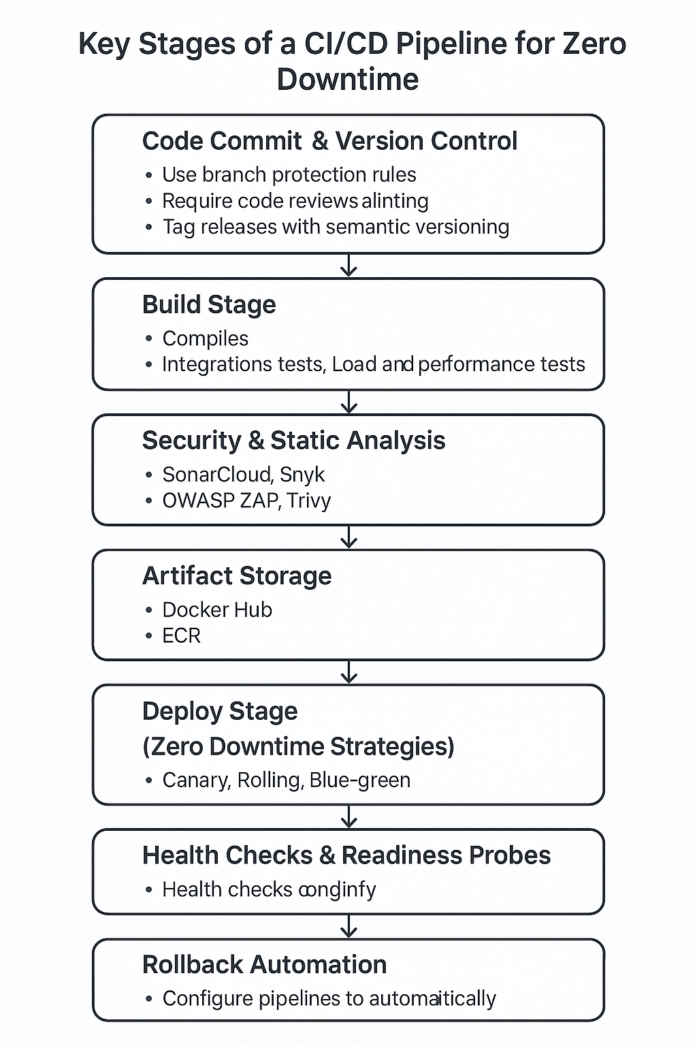

**🏗️ 5. Infrastructure Setup for Zero Downtime Deployment**

Chahe tumhara CI/CD pipeline kitna bhi strong ho, bina resilient infrastructure ke Zero Downtime possible nahi hai.  
Yahan hum baat karenge kaise cloud ya on-prem infra ko design aur configure karte hain jisse deployment non-disruptive rahe.

**1. Load Balancers**

Kaam: Traffic ko multiple app instances mein distribute karna.

**Kyu Zaruri Hai?**

* Sirf healthy instances traffic serve karenge.
* Rolling, Blue-Green, Canary deployment easy hoti hai.

**Popular Load Balancers:**

* AWS ALB/ELB
* NGINX / HAProxy
* Azure Load Balancer
* Traefik (K8s Native)

**2. Auto-Scaling Groups**

**Kaam:** Load ke hisaab se instances ko automatically scale up ya scale down karna.

**Use Cases:**

* Updated instances replace karna.
* Blue-Green ya Canary deployment mein naye nodes spin karna.

**Kubernetes Example** (Horizontal Pod Autoscaler)

**3. Immutable Infrastructure**

Concept: Live servers ko modify karne ke bajay nayi machines deploy karo.

**Tools:**

1. Terraform / Pulumi (Provisioning ke liye)

2. Packer (Golden images banane ke liye)

3. Kubernetes (YAML manifests se deployment)

**4. Service Discovery**

Deployment ke time par containers ke IPs change hote hain, Service Discovery se apps apas mein easily connect kar sakte hain.

**Popular Tools:** Kubernetes DNS (built-in)

* AWS Cloud Map / ECS Service Discovery
* HashiCorp Consul

**5. Database Redundancy & Resilience**

App deploy zero-downtime mein ho sakta hai, lekin database downtime ka bada risk hota hai.

**Best Practices:**

* Managed DBs lo (AWS RDS, Cloud SQL) with Multi-AZ setup.
* Automatic backups + replication enable karo.
* Schema changes ke liye online migrations ka use karo.

**AWS RDS Example (Multi-AZ):**

* Active-Passive replication
* Automatic failover in case of failure

**6. Network Design & Isolation**

Infrastructure ko alag layers mein divide karo for better security aur reliability.

**Best Practices:**

* Public vs. Private subnets ka use karo.
* Staging aur Production ke liye alag VPCs banao.
* Security groups aur firewalls se tight access control rakho.

**AWS VPC Example:**

* Public Subnet: ALB, NAT Gateway
* Private Subnet: App Servers, Databases
* Route Tables: NAT gateway se private servers ka internet access

**7. Container Orchestration (Kubernetes / ECS)**

Dynamic scaling, rolling updates aur service health ke liye container orchestrators best hain.

**Benefits of Kubernetes:**

* Declarative YAML se infrastructure
* Rolling updates out-of-the-box
* Health check aur service discovery built-in

**8. Observability Infrastructure**

Jo cheez dikhti hai wahi manage hoti hai. Monitoring zaruri hai!

**Include karo:**

* Centralized Logging (ELK Stack, Loki, CloudWatch)
* Metrics Monitoring (Prometheus + Grafana)
* Distributed Tracing (Jaeger, Zipkin, AWS X-Ray)

**Grafana Example Panels:**

* Uptime %
* Pod restarts
* Request latency spikes during deploys

**🎯 Bonus: Infrastructure as Code (IaC)**

Poora infra code mein likho!

**Tools:**

* Terraform (Infra provisioning)
* Helm / Kustomize (Kubernetes manifests)
* GitHub Actions / GitLab CI (Automation)

**✅ Repeatability, traceability aur full automation guarantee milti hai — bina downtime ke deployments karne ke liye.**

**⚡ Ek Line Mein Summary:**

"Resilient infra + smart pipeline = Zero downtime deployment ka asli formula hai!" 🔥

**Monitoring, Alerts & Rollbacks**

**1. Health Checks**

Deployment se pehle aur baad mein health checks se app instances ka health status pata chalta hai.

* **livenessProbe:** App alive hai ya nahi?
* **readinessProbe:** App traffic serve karne ke liye ready hai ya nahi?

**Important:** Sirf **readiness probes** pass kar rahe instances ko traffic route karo.

**2. Centralized Logging**

Logs ko har pod ya VM par check karne ki zarurat nahi. Sab logs ko aggregate karna zaruri hai.

**Tools:**

* ELK Stack (Elasticsearch + Logstash + Kibana)
* Loki + Grafana
* AWS CloudWatch Logs
* Azure Monitor

**3. Application Metrics**

Real-time dashboards help in identifying:

* Errors spike ho rahe hain?
* Latency badh rahi hai?
* Requests fail ho rahi hain?

**Tools:**

* Prometheus + Grafana (Self-hosted)
* DataDog, New Relic, Sentry (Managed)
* AWS CloudWatch Metrics

**4. User Behavior Monitoring**

Sirf servers ko monitor karna kaafi nahi hai. Kya users ko koi issue ho raha hai?

**Tools:**

* Sentry (Frontend + Backend error tracking)
* FullStory / Hotjar (Session replay)
* PostHog / Mixpanel (Event analytics)

Yeh tools show karenge:

* JS errors after deployment
* Checkout ya click-through rates ka drop
* Rage clicks (frustrated users)

**5. Automated Alerts**

Set karo thresholds jisse real-time alerts trigger ho sakte hain jab kuch galat ho.

**Alert Channels:**

* Slack / Microsoft Teams
* PagerDuty
* Email / SMS

**6. Deployment Monitoring in CI/CD**

CI/CD tools se post-deployment health track karo:

* **GitHub Actions:** Use checks ya wait-for-deployment steps.
* **ArgoCD / Flux:** Sync status aur rollback agar degraded ho.
* **Jenkins:** Custom build stages for canary observability.

**7. Automatic Rollbacks:** Agar error rates spike ho ya health checks fail ho, to **automatic rollback** karo.

**Tools jisme rollback integrated ho sakta hai:**  
ArgoCD (Auto-sync with rollback)  
  
Spinnaker  
  
GitLab Auto DevOps

**8. Post-Deployment Verification**

Deployment ke baad:

* Synthetic tests run karo
* Test transactions verify karo
* Key user flows validate karo

**Tools:**

* **Cypress / Playwright** (End-to-End Testing)
* **Postman Monitor** (API Testing)
* **Selenium Grid** (UI Testing)